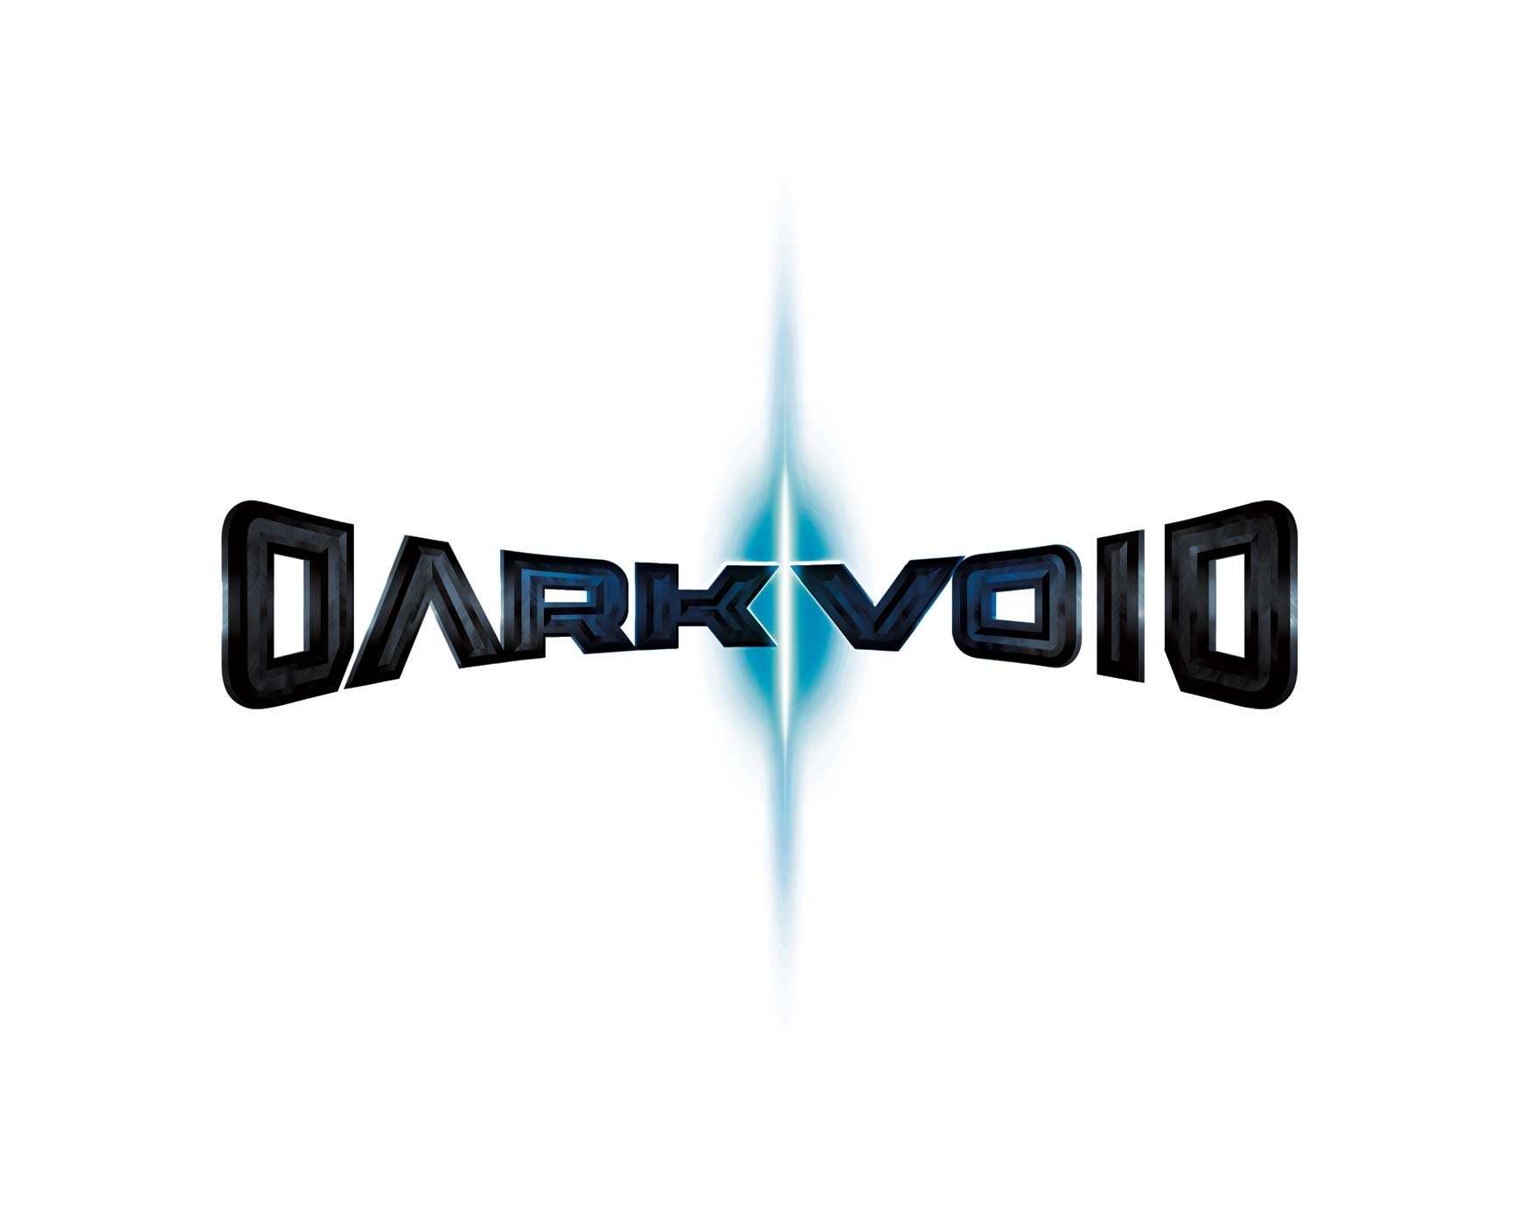

Release Date: TBC
Genre: Sci-Fi Action-Adventure
Platform: 360, PS3 and PC
Rating: TBC
Developer: Capcom Entertainment
Price: TBC
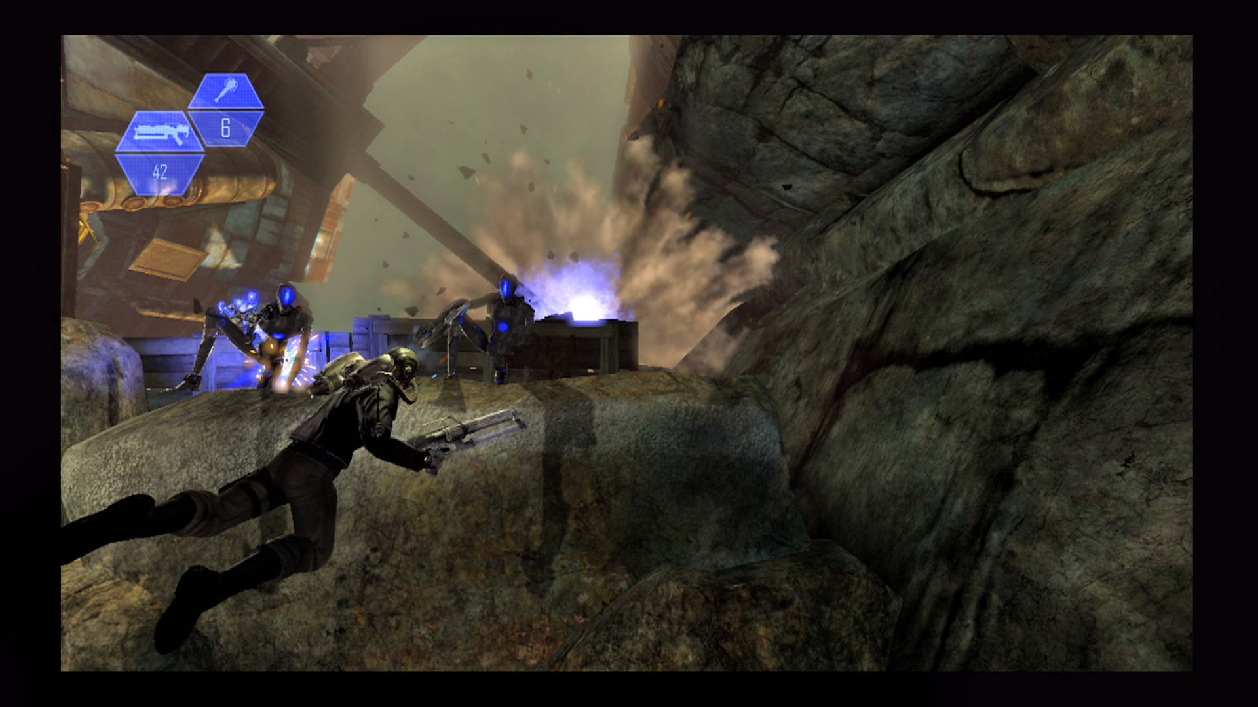
Dark Void is a new sci-fi action-adventure game that combines an adrenaline-fuelled blend of aerial and on-foot combat set in a parallel universe called “The Void”. Players will take on the role of Will; a pilot who while on a routine air cargo flight crashes in the Bermuda triangle leading him to be trapped in the Void. Will soon finds himself swept into a desperate struggle for survival at the head of a group called The Survivors. Trapped in the Void, these resistance fighters are battling to hold off a mysterious alien race that plans to threaten Earth.

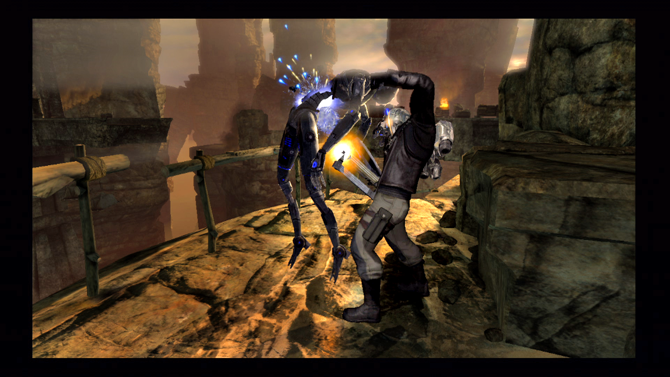
Dark Void’s unique combination of in-air and on-ground combat creates a thrilling new gameplay dynamic to the third-person shooter experience. Dark Void’s unique vertical combat system allows players to dangle from thousand foot drops as they take cover and take out enemies from above and below, bringing a real sense of vulnerability and intensity to the player.

Defying gravity in vertical combat is only half the battle as, Will’s endeavours are rewarded with upgrades to his rocket pack allowing fierce in-air combat as gamers fly through the Void at terrifying speeds shooting down anything that gets in their path. Blasting away at massive bosses has never been this much fun as Dark Void offers a unique grip system made up of a variety of grip-based mini-games including skyjacking UFOs mid-flight.

Features
- Sci-Fi Action-Adventure combines aerial and on-foot combat for unparallel 3D third-person shooter experience
- Gravity-defying vertical combat system where moving up is the only way to bring your enemies down
- Unique grip system that allows the players to scale walls jumping from surface to surface or hijack UFO’s while in mid-air
- Explosive hover and rocket pack and special in-air moves allow players to fly with reckless abandon while performing hair-raising stunts
- The Void- a mind-bending parallel world where an evil alien race called, “The Watchers” are waiting…
- Mysterious thought-provoking storyline based on conspiracy theory and strange phenomenon

